Performance Evaluation of Wind Turbine Primary Frequency Regulation Methods under Inertial Support Action
A.B. Author*, C.D. Author †
*Affiliation,Country and contact details
†Affiliation,Country and contact details
Affiliation,Country and contact details
Affiliation,Country and contact details

Abstract/synopsis:
Objectives and context
The share of renewable sources in the installed capacity continues to raise each passing day. Renewable sources not only bring promising results in the environmental issues but also cause operational problems in the electricity grid. This is why grid operators start asking for additional services from renewable sources. One of these additional services is inertial support from wind turbines. Due to power electronics, grid frequency has no influence on rotational speed of the turbine. Therefore, inertia existing in the turbine blades and generator is not reflected to grid side. By emulating the synchronous generator behaviour, these frequency deviations can be reflected to turbine speed. Hence, the turbine output power can be increased or decreased by extracting or storing the kinetic energy in turbine inertia depending on the frequency deviation direction. Another additional service is the primary control. Most of the conventional generation units is utilized below the rated power. In this way, output power can be increased if the frequency decreases. For now, wind power plants are operated in Maximum Power Production Point due to economic reasons. However, this increases the responsibility of the remaining conventional generation units. In the future, all generation units including the renewable sources are expected to participate primary frequency control action which does not extract whole available wind power.
Methods/approach
Wind turbines are operated in a point which captures maximum power from wind. For the primary control action, wind turbines are required to operate below this maximum power. Wind turbine can reach such operation by either changing pitch angle or turbine speed. In normal operation, pitch angle is used for curtailing the captured power in high wind speeds. Therefore, changing the pitch angle is one way of de-loading the turbine. In Figure 1, power curtailment by changing pitch angle is shown. By using this method, power can be curtailed without changing the turbine speed. However, the rate of change of pitch angle is limited due to mechanical time constant. In other words, it is not possible to change pitch angle immediately.
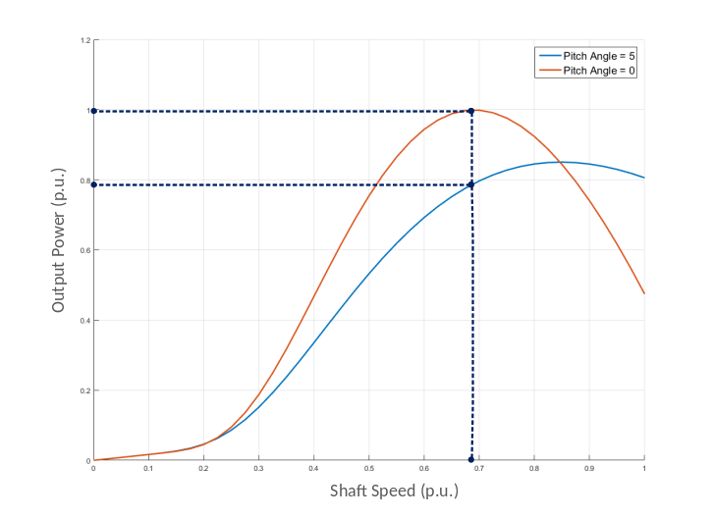
Figure 1. Pitch Angle De-Load
Another way to curtail active power is either decreasing or increasing the speed of the turbine. Note that in Figure 2, there are two different speeds corresponding to a defined power value. Due to fact that the lower speed would store less kinetic energy, high speed is more appropriate for primary frequency control. Therefore, primary reserve in a wind turbine can be achieved by either increasing the pitch angle or shaft speed. In this study, these primary control methods will be compared for inertial support performance.

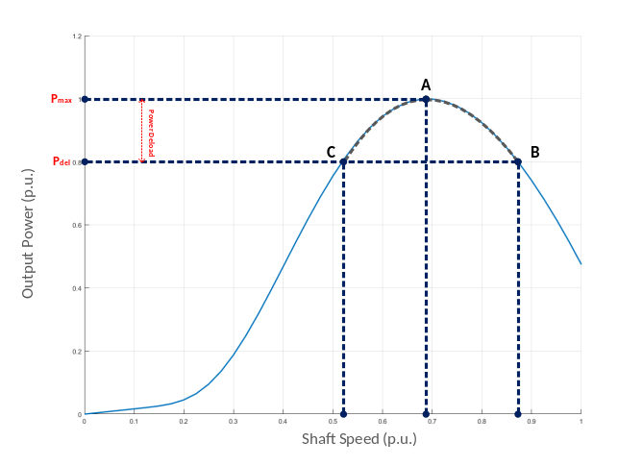
Figure 2. Shaft Speed De-Load
Outcomes
Inertial support methods allow wind turbines to increase its power output for small time intervals by making use of the kinetic energy stored in the total turbine inertia. As a result, turbine operation leaves the maximum power point and turbine speed decreases. One disadvantage is that the turbine speed should be recovered by decreasing the power output at the end of the support. However, both primary control methods will not experience speed recovery period resulting no power reduction after frequency support. Moreover, primary control with over-speeding action would have more kinetic energy than primary control with increased pitch angle. Therefore, the over-speeding action is expected to exhibit better performance. Furthermore, it is another fact that high speed operation for same rating machines would results less copper losses. Therefore, another expectation is that over-speeding action is expected to be more efficient.
Conclusions
At the end of this study, primary control methods will be compared in terms of inertial support performance. A wind turbine can be de-loaded either increased pitch angle or increased turbine speed methods. The performance of these methods with inertial support will be evaluated at the end of this study. However, over-speeding method is expected to demonstrate better performance due to higher kinetic energy storage and better efficiency.

